The HTTP Protocol

*Before you start, you should create a document (or a just a piece of paper) where you should write down the Status Code generated by each of the following exercises (You need this for exercise 4-c)*

1) Monitoring HTTP Headers 1

Create a new NetBeans Maven Web-project.

For this exercise, we will just use the default index.html generated by NetBeans.

Press the run button. When you see the file in the browser (Chrome), open the network tab in the developer window (Windows: Ctrl-shift-j / Mac: Option-Command-i) and press F5

Observe and explain each of the values monitored (use view source to see the plain messages).

Index.html filen, som er den der bliver vist

Favicon.ico som er tomcat logoet.

Hints: In order to better observe the values related to Caching you might need to:

Go back to NetBeans and rename your file to index1.html

Go back to your browser and (while the developer window is open) change the url to point to the new file.

Observe the values

Press F5 and observe the values again.

Explain what you see.

2) Monitoring HTTP Headers 2

Add an image to the page

Add an external style sheet to the page <link rel="stylesheet" type="text/css" href="myStyle.css">

Reload the page again, observe the request(s) being made, and explain the purpose of the connection header.

Kontrollerer og bestemmer om hvorledes forbindelsen forbliver åben efter den nuværende transaktion. Med fx keep-alive er forbindelsen persistent og tillader flere requests til samme server.

3) Monitoring HTTP Headers 3  (Response-codes 3xx)

In the Web-project, created for 1+2, add a new HTML-page called **r.html** and add this text in an h1-tag “**You got redirected to me**”.

Use the Wizard to create a servlet called redirect

Remove the processRequest and the doPost method completely from the generated servlet-code.

In the doGet(..) method replace the call to processRequest with this line: response.sendRedirect("r.html");

While your server is running, open a (Chrome) browser, and Developer Tools and the network tab.

Enter the address for the servlet (**http:localhost:8080/redirect)** into the browser and explain:

* The two HTTP-request you see

How the browser knew where to go in the second request  
  
Første gang har du redirect liggende som smider en 302, som er redirect.   
  
anden gang du refresher er du på den anden side (r.html) og du genloader bare den side og bliver aldrig redirected.

3a) Redirecting to HTTPs instead of HTTP

In Chrome enter this address (with the developer window + the network-tab open), and exactly as it is spelt: [**http://studypoints.info**](http://studypoints.info)

Explain the first two request monitored (notice where you requested to go, and where you actually ended).

Important: Later this week, you will learn how to set up your own server to use https, and ONLY https.  
  
<http://studypoints.info> -> <https://studypoints.info/#/view1> med koden 301 - Moved permanently

4a) Status Codes (5xx)

Use the Wizard to create a servlet called **Ups**

In the processRequest(..) method,  just before the try-statement add this code:

int result = 100/0;

While your server is running, open Chrome developer tools and the network tab and then call the servlet.

Write down the response code generated by the server as for the previous exercises

Man får kode 500, da servletten kaster en undtagelse.

4b) Status Codes (4xx)

While your server is running, open Chrome developer tools and the network tab, and call this address: **http://localhost:8080/i_dont_exist**

Write down the response code generated by the server as for the previous exercises

404 –not found

4c) Status Codes - Ranges

Your document, containing the Status Codes for all the exercises done so far, should now contain codes like 2xx, 3xx, 4xx and 5xx.

Explain (write down your answer so you won’t forget) the meaning of the first digit in the 3-digit Status Codes you have seen so far.  
  
2xx -> success

3xx -> redirection

4xx -> client error

5xx -> server error

5) Get HTTP Request Headers on the Server

We have seen that an HTTP request from a Browser typically includes a lot of headers with information related to the client.

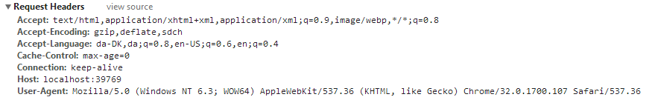

This information is available to a servlet (actually to any web-server technology)  via the request object. Create a Servlet, which should output this information in a table as sketched in this figure (or in any way you like, but don’t focus on presentation).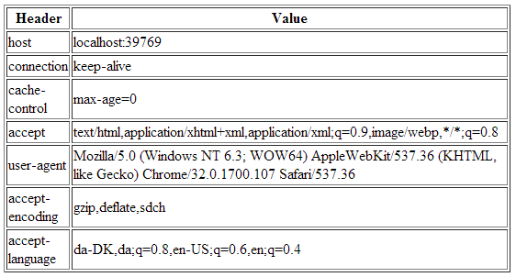

*Hints: Use the request objects getHeaderXXX methods.*

6) Get/Post-parameters

Create a new HTML-file in the web-project made in exercise 1.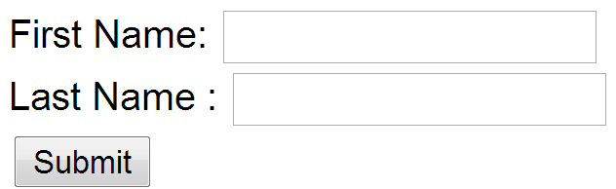

Add a form to the file, including two text input boxes and a submit button as sketched below:

Add an extra input field to the form with type=”hidden”, name=”hidden” and value=12345678.

Add the value “#” for the forms action attribute.

Set the forms method-attribute to the value “GET” (actually the default value) and test the form. Observe what happens in your browser's address field.

* Hidden værdien og værdien af first og last name bliver tilføjet til URLen, sammen med afsluttet med formens action og ligger som query string parameters

Change the forms method-attribute to the value “POST” and test the form. Observe the change in your browsers address field. Figure out (using Chrome Developer Tools), how parameters are passed in, for a POST request.  
  
Write down your observations

* Hidden værdien og værdien fra felterne bliver ikke sendt som en del af urlen men ligger under form data

Session and Cookies

*For the next two exercises/demos you should create a new Maven web-project. Both the demos use a Servlet.*

7)      Sessions (Session Cookies)

In your web project use the wizard to generate a  new Servlet

1. Enter ***SessionDemo*** as the name of the Servlet and *servlets* as package name
2. Right-click the file and select Run to see “what is does” -> servlet SessionDemo at w2d2b
3. Change the generated processRequest(..) method as sketched below.

protected void processRequest**(**HttpServletRequest request**,**

                              HttpServletResponse response**)**

**throws** ServletException**,** IOException **{**

    String name **=** request**.**getParameter**(**"name"**);**

**if** **(**name **!=** **null)** **{**

      request**.**getSession**().**setAttribute**(**"name"**,** name**);**

**}** **else** **{**

      name **=** **(**String**)** request**.**getSession**().**getAttribute**(**"name"**);**

**}**

    response**.**setContentType**(**"text/html;charset=UTF-8"**);**

**try** **(**PrintWriter out **=** response**.**getWriter**())** **{**

      out**.**println**(**"<!DOCTYPE html>"**);**

      out**.**println**(**"<html>"**);**

      out**.**println**(**"<head>"**);**

      out**.**println**(**"<title>Servlet SessionDemo</title>"**);**

      out**.**println**(**"</head>"**);**

      out**.**println**(**"<body>"**);**

**if** **(**name **!=** **null)** **{**

        name **=** **(**String**)**request**.**getSession**().**getAttribute**(**"name"**);**

        out**.**println**(**"<p> Welcome " **+** name  **+** " !</p>"**);**

**}** **else** **{**

        out**.**println**(**"<h2>Please enter your name, and submit</h2>"**);**

        out**.**println**(**"<form action='SessionDemo'>"**);**

        out**.**println**(**"<input type='input' name='name'>"**);**

        out**.**println**(**"<input type='submit'></form>"**);**

**}**

      out**.**println**(**"</body>"**);**

      out**.**println**(**"</html>"**);**

**}**

**}**

1. Enter your name and press submit, copy the URL in the browser into your clipboard, close the tab (but not the browser) and load the page again in a new tab using the URL in the clipboard.
2. While doing the things in step d, you should monitor the content of your local cookies and the HTTP requests being sent, using the development tools in Chrome.
3. **Most import part of this exercise:**

Explain (on paper) using both words and images how the Server can maintain state between subsequent calls even when the state is not transmitted from the client to server.

Name parametren bliver gemt i sessionen som på tomcat som standard først udløber efter 30 min.

Write down your observations

8)     Persistent Cookies

1. In your web project, use the wizard to generate a new servlet
2. Enter *CookieDemo* as the name of the Servlet and *servlets* as package name
3. Change the generated processRequest(..) method as sketched below.

protected void processRequest**(**HttpServletRequest request**,** HttpServletResponse response**)**

**throws** ServletException**,** IOException **{**

String name **=** request**.**getParameter**(**"name"**);**

**if** **(**name **!=** **null)** **{**

Cookie cookie **=** **new** Cookie**(**"username"**,** name**);**

cookie**.**setMaxAge**(**60 **\*** 60 **\*** 24 **\*** 365**);**

response**.**addCookie**(**cookie**);**

**}**

Cookie**[]** cookies **=** request**.**getCookies**();**

**if** **(**cookies **!=** **null)** **{**

**for** **(**Cookie cookie **:** request**.**getCookies**())** **{**

**if** **(**cookie**.**getName**().**equals**(**"username"**))** **{**

name **=** cookie**.**getValue**();**

**}**

**}**

**}**

response**.**setContentType**(**"text/html;charset=UTF-8"**);**

**try** **(**PrintWriter out **=** response**.**getWriter**())** **{**

/* TODO output your page here. You may use following sample code. */

out**.**println**(**"<!DOCTYPE html>"**);**

out**.**println**(**"<html>"**);**

out**.**println**(**"<head>"**);**

out**.**println**(**"<title>Servlet CookieDemo</title>"**);**

out**.**println**(**"</head>"**);**

out**.**println**(**"<body>"**);**

**if** **(**name **!=** **null)** **{**

out**.**println**(**"<p> Welcome " **+** name **+** " !</p>"**);**

**}** **else** **{**

out**.**println**(**"<h2>Please enter your name, and submit</h2>"**);**

out**.**println**(**"<form action='CookieDemo'>"**);**

out**.**println**(**"<input type='input' name='name'>"**);**

out**.**println**(**"<input type='submit'></form>"**);**

**}**

out**.**println**(**"</body>"**);**

out**.**println**(**"</html>"**);**

**}**

**}**

1. Enter your name and press submit, copy the URL in the browser into your clipboard, close the tab (but not the browser) and load the page again in a new tab using the URL in the clipboard.
2. Now close your browser (you could even close your laptop, but don’t ;-) , open it again and load the page again using the URL in the clipboard
3. While doing the things in step e, you should monitor the content of your local cookies and the HTTP requests being sent, using the development tools in Chrome.
4. **The most import part of this exercise:**

Explain (on paper) how Cookies can be used to maintain “state” on the client between subsequent calls to a server, even when a browser has been closed down.

Write down your observations

Cookies kan bruges til at gemme vigtige værdier mellem besøg på en hjemmeside på klientens side. Så næste gang du går på just-eat fra din computer, kan den huske hvad du havde i indkøbskurven sidst, selvom du ikke var logget ind.  
Eller der kan huskes diverse parametre eller indstillinger fra din computer.